**Industrial Internship Report on**

**Banking Information System**

**Prepared by**

**R. Sandeep Gowda**

|  |
| --- |
| *Executive Summary* |
| This report provides details of the Industrial Internship provided by Upskill Campus and The IoT Academy in collaboration with Industrial Partner UniConverge Technologies Pvt Ltd (UCT).  This internship was focused on a project/problem statement provided by UCT. We had to finish the project including the report in 6 weeks’ time.  My project was to develop a prototype of a **Banking Information System** in Core Java that provides a working preview of the key functionalities of a real banking system. The prototype that I had to design was required to demonstrate the core features and flow of the system, showcasing its functionality and usability.  This internship gave me a very good opportunity to get exposure to Industrial problems and implement solution for that. It was an overall great experience to have this internship. |

**TABLE OF CONTENTS**

1 Preface 3

2 Introduction 5

2.1 About UniConverge Technologies Pvt Ltd 5

2.2 About upskill Campus 9

2.3 Objective 10

2.4 Reference 11

2.5 Glossary 10

3 Problem Statement 12

4 Existing and Proposed solution 15

5 Proposed Design/ Model 16

5.1 High Level Diagram (if applicable) 16

5.2 Low Level Diagram (if applicable) 16

5.3 Interfaces (if applicable) 17

6 Performance Test 28

6.1 Test Plan/ Test Cases 29

6.2 Test Procedure 29

6.3 Performance Outcome 29

7 My learnings 30

8 Future work scope 30

# Preface

This 6 weeks’ internship has been a great learning experience.

* In the First week, I explored the problem statement and about UCT and started implementing the project. I designed a basic working structure of the Banking Information System having functionalities of : 1)Register, 2)Log in ,3) Deposit, 4)Withdraw and 5)Money transfer.
* In the second week according to the instructions and my plan I kept adding some features, I built the module for ‘Account Management’, in which I included features such as 1)Update name ,2)Update Address ,3)Update contact details and 4)Password settings.
* In the third week working on the project, I  built the module for ‘Account Statement’, in which I have made a provision to view the latest transactions of the account to which an user is currently logged into.
* In the fourth week,  I made a few minor changes to the previous code and tried to refine the code as much as possible. I added exception handling mechanisms where ever needed to prevent as much error as possible due to input mistakes. I revised the entire code and made changes that made my code closer to perfection .
* In the fifth week, I have added a module , made a few minor changes to the previous code, and tried to refine the code as much even further as possible. I added the code to Log out from the Banking Information as the last module for my project. Although it was not explicitly mention to include ‘Log out’ in the list of required system features in the problem statement, but I felt it is necessary to make the project complete.
* And finally in the sixth week I did some testing and prepared the Final Project Report. According to the problem statement I have also implemented basic data persistence as well. The prototype can successfully demonstrate all these functionalities with no errors.

I think hands- on knowledge of all the concepts that I learnt though this project internship have added a lot more value than theoretical knowledge would ever have. This internship opportunity helped me solve a real world problem ,and learn a lot from it. This internship is very relevant and designed in a manner that is just right for the present day industry scenario.

My project was to develop a prototype of a **Banking Information System** in Core Java that provides a working preview of the key functionalities of a real banking system. The prototype that I had to design demonstrates the core features and flow of the system, showcasing its functionality and usability.

I would like to express my gratitude to Upskill Campus and The IoT Academy for giving me the opportunity to work on this project.

The program was planned in an excellent manner. The lecture videos , notes, quizzes were great, and they helped me to learn a lot from them. My project implementation also helped me learn so much more. From learning concepts to facing errors ,to debugging them , correcting them. Every step gave an

awesome learning experience. It was great to mention about all Challenges and Hurdles faced week wise in the Weekly Reports as well as the Lessons learnt from them. This gave a me self evaluation which provides an opportunity to self-reflect on their strengths and weaknesses.

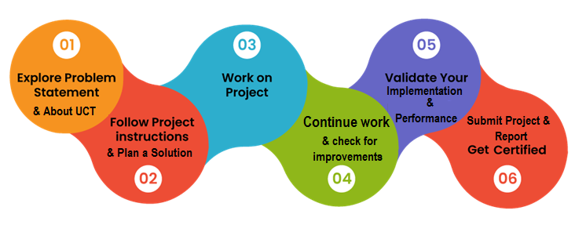

I learned a lot in these six weeks, all the weekly reports have details of which, but to mention an important one - I think hands- on knowledge of all the concepts that I learnt though this project have added a lot more value than theoretical knowledge would ever have. Solving problems by debugging my code and fixing the issues faced by me also helped me learn a lot of this skill. Earlier debugging my own code used to be very difficult but via this project slowly and steadily I have mastered this skill . It was a great overall experience.

Thanks to Upskill Campus and The IoT Academy for giving me the opportunity to work on this project.

My message to peers and juniors would be that : you should definitely apply for this internship. It is an awesome learning opportunity. Besides it’s great learning experience and values adding nature, It will provide a boost to your CV and career as the internship will be a valuable addition that will help you in your future endeavors.

# Introduction

## About UniConverge Technologies Pvt Ltd

A company established in 2013 and working in Digital Transformation domain and providing Industrial solutions with prime focus on sustainability and RoI.

For developing its products and solutions it is leveraging various**Cutting Edge Technologies e.g. Internet of Things (IoT), Cyber Security, Cloud computing (AWS, Azure), Machine Learning, Communication Technologies (4G/5G/LoRaWAN), Java Full Stack, Python, Front end**etc.

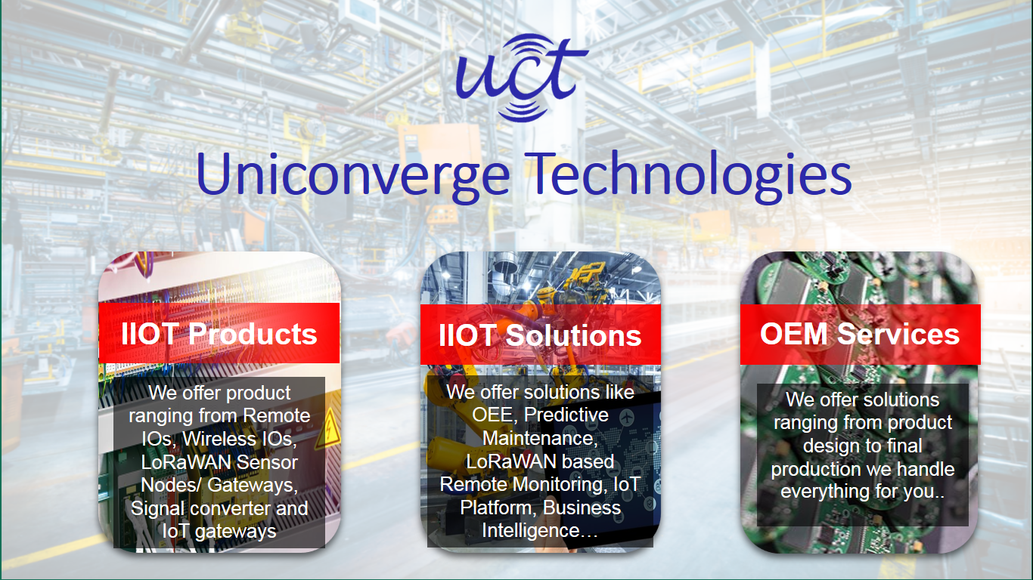

1. UCT IoT Platform **(****)**

**UCT Insight** is an IOT platform designed for quick deployment of IOT applications on the same time providing valuable “insight” for your process/business. It has been built in Java for backend and ReactJS for Front end. It has support for MySQL and various NoSql Databases.

* It enables device connectivity via industry standard IoT protocols - MQTT, CoAP, HTTP, Modbus TCP, OPC UA
* It supports both cloud and on-premises deployments.

It has features to  
• Build Your own dashboard  
• Analytics and Reporting  
• Alert and Notification  
• Integration with third party application(Power BI, SAP, ERP)  
• Rule Engine

 

1. **Smart Factory Platform (****)**

Factory watch is a platform for smart factory needs.

It provides Users/ Factory

* with a scalable solution for their Production and asset monitoring
* OEE and predictive maintenance solution scaling up to digital twin for your assets.
* to unleased the true potential of the data that their machines are generating and helps to identify the KPIs and also improve them.
* A modular architecture that allows users to choose the service that they what to start and then can scale to more complex solutions as per their demands.

Its unique SaaS model helps users to save time, cost and money.



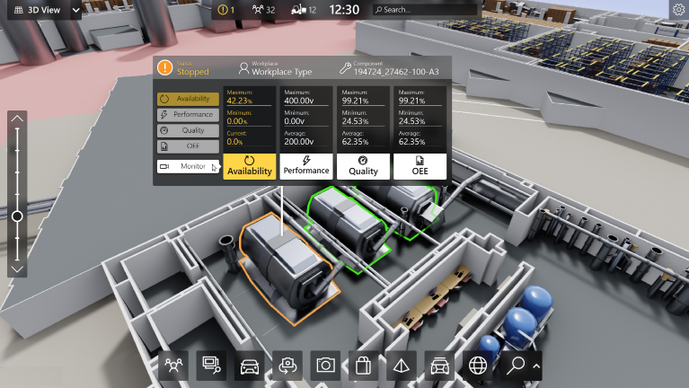

1.  based Solution

UCT is one of the early adopters of LoRAWAN teschnology and providing solution in Agritech, Smart cities, Industrial Monitoring, Smart Street Light, Smart Water/ Gas/ Electricity metering solutions etc.

1. Predictive Maintenance

UCT is providing Industrial Machine health monitoring and Predictive maintenance solution leveraging Embedded system, Industrial IoT and Machine Learning Technologies by finding Remaining useful life time of various Machines used in production process.



## About upskill Campus (USC)

upskill Campus along with The IoT Academy and in association with Uniconverge technologies has facilitated the smooth execution of the complete internship process.

USC is a career development platform that delivers **personalized executive coaching** in a more affordable, scalable and measurable way.

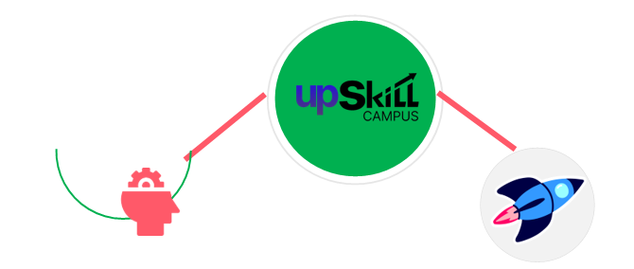

Seeing need of upskilling in self paced manner along-with additional support services e.g. Internship, projects, interaction with Industry experts, Career growth Services

<https://www.upskillcampus.com/>

upSkill Campus aiming to upskill 1 million learners in next 5 year

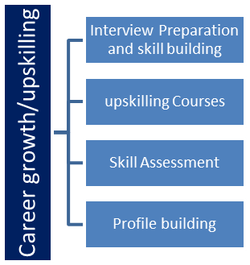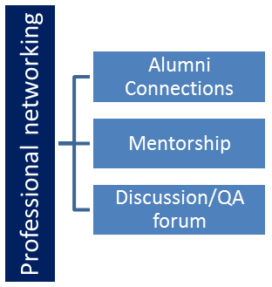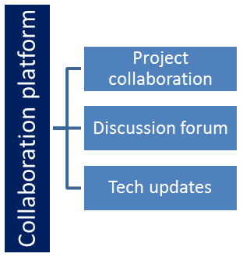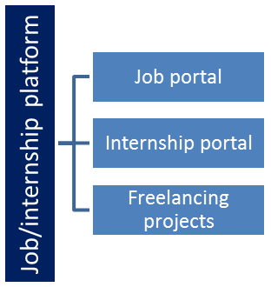

## The IoT Academy

The IoT academy is EdTech Division of UCT that is running long executive certification programs in collaboration with EICT Academy, IITK, IITR and IITG in multiple domains.

## Objectives of this Internship program

The objective for this internship program was to

 ☛ get practical experience of working in the industry.

 ☛ to solve real world problems.

 ☛ to have improved job prospects.

 ☛ to have Improved understanding of our field and its applications.

 ☛ to have Personal growth like better communication and problem solving.

## Reference

[1] https://www.w3schools.com/java/java_switch.asp

[2] https://www.javatpoint.com/exception-handling-in-java

## Glossary

|  |  |
| --- | --- |
| Terms | Acronym |
| Integrated Development Environment | IDE |
| Not Applicable | N/A |
|  |  |
|  |  |
|  |  |

# Problem Statement

The assigned problem was:

Problem Statement for the Project: Banking Information System

Develop a prototype of a Banking Information System in Core Java that provides a working preview of the key functionalities of a real banking system. The prototype should demonstrate the core features and flow of the system, showcasing its functionality and usability.

Key Functionality to Include in the Prototype:

1. User Registration: Implement a simplified user registration process where users can provide basic details to create an account.
2. Account Management: Develop the ability to create and manage user accounts, including assigning unique account numbers and tracking account balances.
3. Deposit and Withdrawal: Enable users to make deposits and withdrawals from their accounts, updating the account balance accordingly.
4. Fund Transfer: Implement a simplified version of fund transfer functionality, allowing users to transfer funds between their accounts or to other registered users.
5. Account Statements: Provide users with a preview of their account statements, displaying transaction history, dates, amounts, and remaining balances.
6. Password Protection: Develop a basic login system with password authentication to ensure secure access to user accounts.
7. Error Handling: Implement basic error handling mechanisms to handle common exceptions, such as insufficient funds and invalid transactions, and display relevant error messages to users.
8. User Interface: Design a user-friendly interface for the prototype that allows users to navigate through the system, perform banking operations, and view relevant information.
9. Persistence: Implement basic data persistence by storing user account information and transaction history temporarily during the prototype session.

By developing this prototype, stakeholders will have a tangible working preview of the key features and functionality of the Banking Information System. This will allow them to evaluate the system's usability, identify any necessary improvements or enhancements, and make informed decisions for further development and deployment of the complete system.

Minimum Requirements and System Output

1. User Registration:

* Form Creation: Create a user registration form that prompts users to input their personal details, such as name, address, contact information, and initial deposit amount.
* Output: Upon successful registration, the system will generate a unique account number for the user, and the user's details will be stored in the system's memory or File System.

The output will be a confirmation message indicating successful registration.

2. Account Management:

* Form Creation: Develop an account management form that allows users to view and update their account information, such as name, address, contact details, and account settings.
* Output: After making any updates or changes, the system will display a confirmation message indicating that the account information has been successfully updated.

3. Deposit and Withdrawal:

* Form Creation: Design a form where users can enter the amount they wish to deposit or withdraw from their account.
* Output: Upon successful deposit or withdrawal transaction completion, the system will update the account balance accordingly and display a confirmation message indicating the transaction details, such as the transaction amount and the resulting balance.

4. Fund Transfer:

* Form Creation: Create a form that allows users to specify the recipient's account number and the amount they wish to transfer.
* Output: After a successful fund transfer, the system will deduct the transferred amount from the sender's account, add it to the recipient's account, and display a confirmation message indicating the transaction details, including the transferred amount and the updated balances of both accounts.

5. Account Statements:

Output: Implement a feature that allows users to view their account statements, which will be displayed as a comprehensive list showing transaction history, including dates, transaction amounts, and resulting balances. Users can access their account statements through a designated section of the system's user interface.

# Existing and Proposed solution

When I did some research on this topic, I saw many people have implemented this project but none of which contained all the features required by the problem statement.Like for example if they had fund transfer feature, they did not have features like viewing account statements ,updating user details etc. Also projects were implemented using complex coding techniques Advance Java , swing and GUI .None of which were actually required, We basically had to make a console application in **core Java** with a simple user interface. The console terminal interface of the IDE has served this purpose for my project.

In my prototype all the features of the problem statement have been covered.

In future I plan to further improve this project and add many new features and explore way beyond the scope.

## Code submission (Github link)

<https://github.com/DebasmitaSaha/upSkill-Campus-Core-Java-Internship.git>

## Report submission (Github link) :

## <https://github.com/DebasmitaSaha/upSkill-Campus-Core-Java-Internship.git>

## 

# Proposed Design/ Model

I have used Visual Studio Code IDE for implementing my project.

## High Level Diagram – Use case diagram

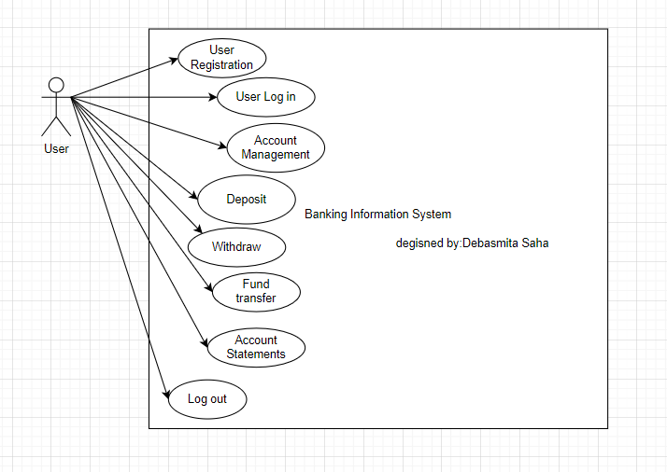

Figure 1: HIGH LEVEL DIAGRAM OF THE SYSTEM

## Low Level Diagram

N/A

## Interfaces

User Interface of console application.

My project can be run on Any IDE that supports running Java Code.

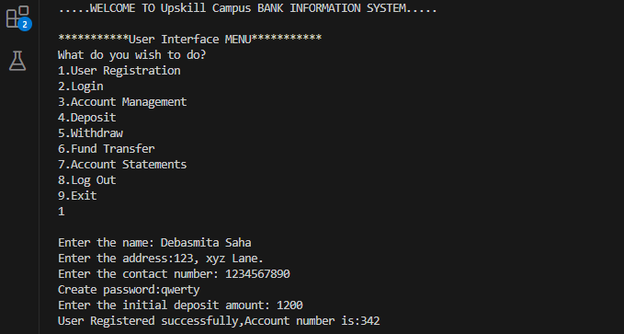

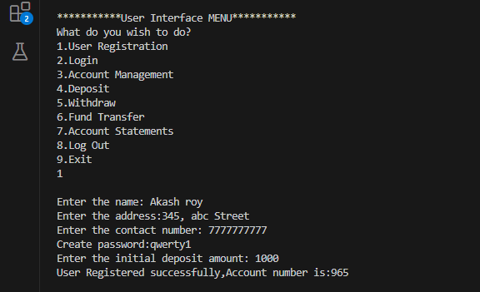

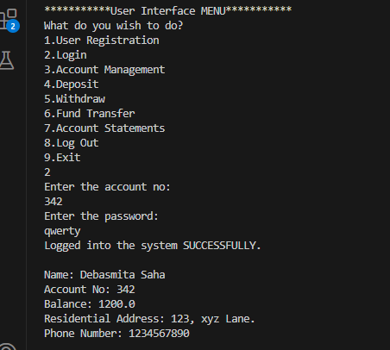

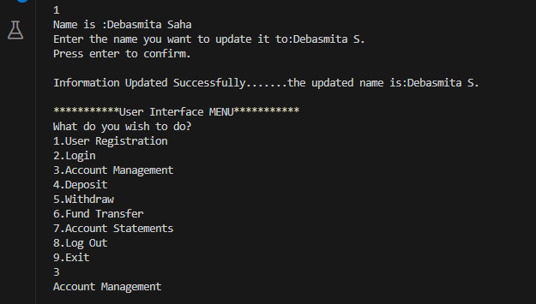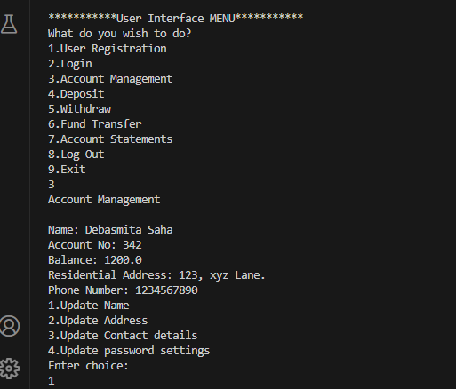

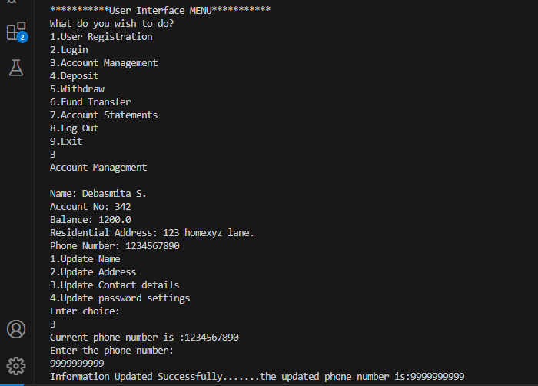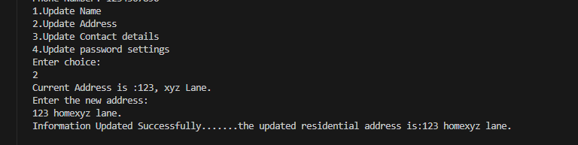

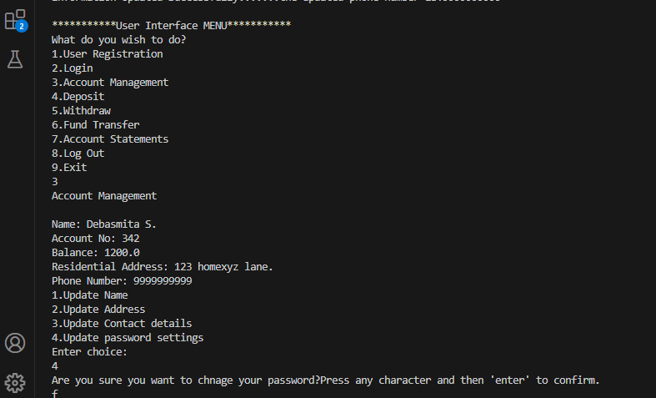

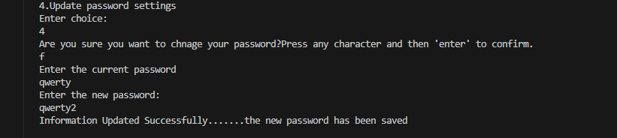

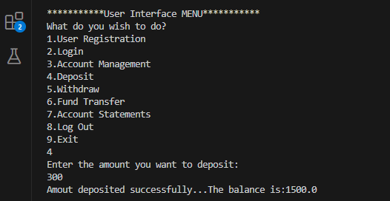

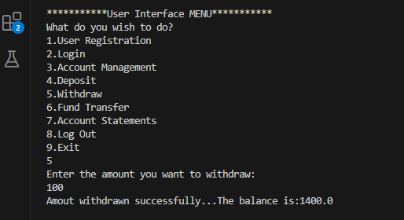

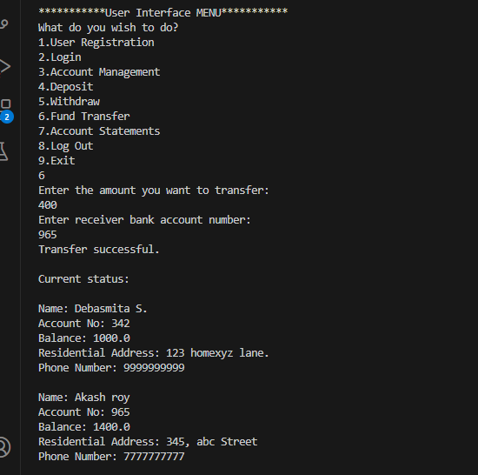

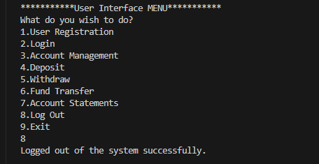

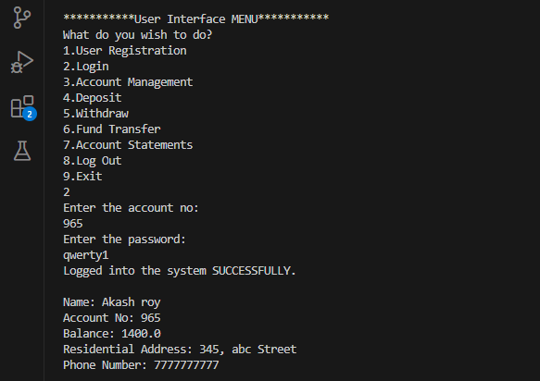

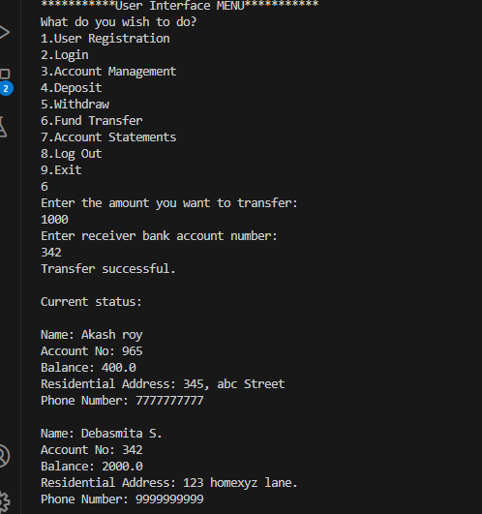

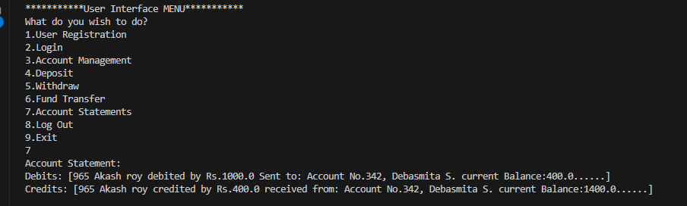

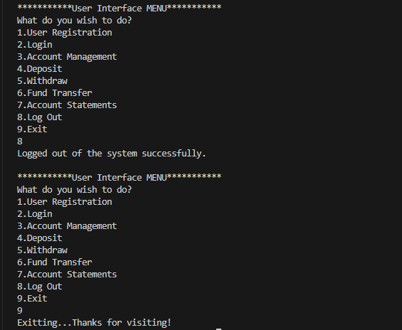

# Performance Test

Error handling capability:

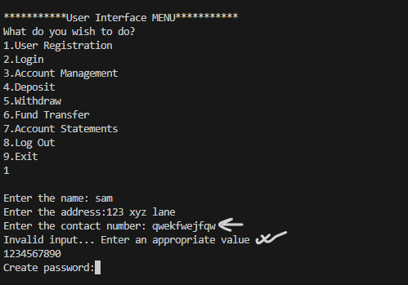

My code is robust and can handle minor errors of variable mismatch types.Other errors have also been covered by me using exception handling so that I can prevent program failure totally.

## Test Plan/ Test Cases

The entire code will all possible use cases has been tested for errors, none encountered. All screenshots have been attached.

## Test Procedure

I have repeatedly run the application as a test procedure to find underlying errors . All screenshots have been attached.

## Performance Outcome

The console application is fast and responds immediately. The response time is almost nill. It may differ from IDE to IDE but when run on any up to date console , the console application should respond similarly.

# My learnings

The program was planned in an excellent manner. The lecture videos , notes, quizzes were great, and helped me learn a lot from them. My project implementation helped me learn so much more from learning to concepts facing errors ,debugging them , correcting them.Every step gave an awesome learning experience. I have mentioned about all Challenges and Hurdles faced week wise in the Weekly Reports as well as the Lessons learnt from them. I think hands- on knowledge of all the concepts that I learnt though this project internship have added a lot more value than theoretical knowledge would ever have. This internship opportunity helped be solve a real world problem ,and learn a lot from it. This internship is very relevant and designed in a manner that is just right for the current industry scenario.

Thanks to to Upskill Campus and The IoT Academy for giving me the opportunity to work on this project.

# Future work scope

Due to time limitation I think, I couldn’t make this project a web application . The future scope of this project would be that this console application can be made into a web application like real world banks have.